Brandt, S. (2008), “Estimation of a Rasch Model Including Subdimensions”, in M. von
Davier and D. Hastedt (eds.), Issues and Methodologies in Large-Scale Assessments,
IEA-ETS Research Institute, Hamburg, Vol. 1. p. 53-71.

In the Rasch family, there are several models to fit a test with testlets:
- Unidimensional model

- Multidimensional model

- Testlet model

Apparently the unidimensional model ignores the relationship among items with a test, so that it usually results in an overestimated reliability. The multidimensional model treats a test as a subtest, and takes account of the relationships among subtests. However, its drawback is that a common scale across subtests is absent. Although the testlet model had a common scale and regarded the issue of local item dependence, the author argued that the constraint on the relationships among testlet effects to be zero is unrealistic. So, the fourth option, subdimensional model, was proposed in the article:
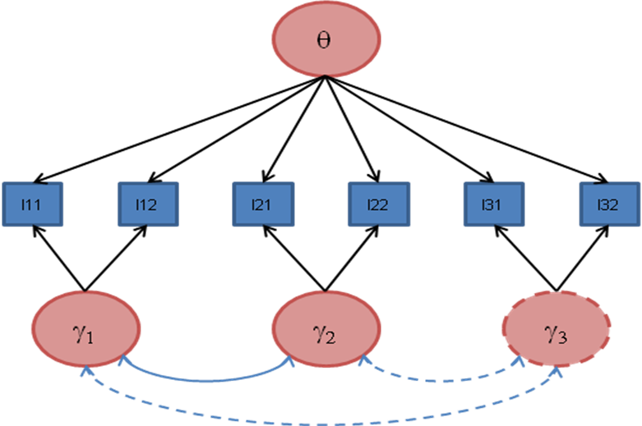

The dash lines suggest that the parameters are constrained and must be computed by hand after calibration. For more details about the restrictions of the model, please refer to page 54. The above models can be realized by inputting special scoring matrix and design matrix in the ConQuest.

- Note that the slash in Table 1 means “or”, not “divide”.
- It is not clear for me to interpret a constrained latent trait.
- Since the relationships among testlet effects are considered, why the author proposed a restricted one, not the models as following diagrams? Aren’t they identifiable models?
