The study examined the performance of a two-level linear growth model over the data from an autoregressive moving average (ARMA) process; specifically, the ARMA process underlies the error structure of the linear growth model.

By simulation, the study determined (a) how well are fixed and random effect parameters and Type I error rates of the tests of fixed effects estimated when correct and incorrect error specifications are used, (b) how effectively do model fit indices work in identifying the correct covariance structure specification, and (c) given that model fit indices may not work well under all conditions, how well does the unstructured error matrix perform when it represents a misspecification.

The results of this study are (1) the estimation procedure converged for all the data sets in this study under four covariance specifications, (2) the estimates of the fixed effects in multilevel linear growth curve modeling appeared to be robust to mismodeled serial correlation when the design was balanced and data were not missing, (3)type I error rates for the tests of the fixed effects were generally accurate when the model was correctly specified or underspecified, (4) random effects were poorly estimated under many conditions, even under correct model specification, and (5) fit criteria performed inconsistently and were especially inaccurate when small sample sizes and short series lengths were combined. Finally, the best performance was obtained by use of an unstructured covariance matrix at the first level of the growth curve model.

Comments

1. However the result that no convergence problems were encountered when series length was 8 and sample size was 30, is somewhat contradictory to the previous research (P.261) that the UN model has the disadvantage that the likelihood functions may cause convergence problems when estimating large numbers of parameters. What is the criterion of this “large”?
2. Why were the random effects poorly estimated even under the correct model specifaction?
3. The equation in page 258 should be

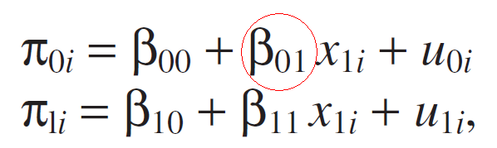

1. Is it enough to set the series length and sample size in 5, 8 and 30,200? Will it be possible that making the simulation range large enough to ensure the sizes of the N, L, by steps, like 30, 5, 0.1, 0.1.